CUI

REQUEST FOR INFORMATION DISCLOSURE

PRIVACY ACT STATEMENT
AUTHORITY10 U.S.C. 3013, Secretary of the Army; 42 U.S.C. 10606; DoD Instruction 1030.1, Victim and Witness Assistance; Army Regulation 600-8-104, Military Personnel Information ManagemenURecords; and E.O. 9397 (SSN).
PURPOSE: These records are created and maintained to manage the member's Army and Army National Guard service effectively, to document historically a member's military service, and safeguard the rights of the member and the Army.
ROUTINE USEs: For additional information see the System of Records Notice A0600-8-104b AHRC, https://dpcld.defense.gov/Privacy/SORNslndex/ DOD-wide-SORN-Article-View/Article/570051/a0600-8-104b-ahrc/
DISCLOSURE: Voluntary, Without the Authorization Signature of the veteran, next-of-kin of deceased veteran, veteran's legal guardian, authorized government agent, or other authorized representative, only limited information can be released.

PLEASE PROVIDE AS MUCH INFORMATION AS POSSIBLE TO ASSIST IN LOCATING THE REQUESTED RECORDS/DOCUMENTS. SOLDIER INFORMATION
LAST NAME |  | FIRST NAME | M.I.
SSN | DOB | SERVICE NUMBER | DISCHARGE DATE
RANK | UNIT
REQUESTORS INFORMATION
NAME (Please Print)
MAILING ADDRESS/STREET ADDRESS |  |  | PHONE NUMBER
CITY |  | STATE | ZIPCODE

RELATIONSHIP TO SOLDIER □ SELF □ SPOUSE □ NEXT OF KIN □ OTHER

NFORMATION/RECORDS REQUESTED
□ □ □ □
DD 214 NGB 22 NGB 23 MEDICAL RECORDS
□ OTHER
THIS INFORMATION IS REQUESTED FOR

SIGNATURE DATE

CONTACT INFORMATION

US MAIL: PHONE / FAX / E_MAIL:

Department of Defense FAX: 207-626-4233
Veterans and Emergency Management E-MAIL: rita.k.gossett.mil@army.mil SHS #33, ATTN: RECORDS TELEPHONE: 207-430-5027
Augusta, ME 04333-0033

DO NOT COMPLETE - TO BE COMPLETED BY MEARNG RECORDS MANAGER

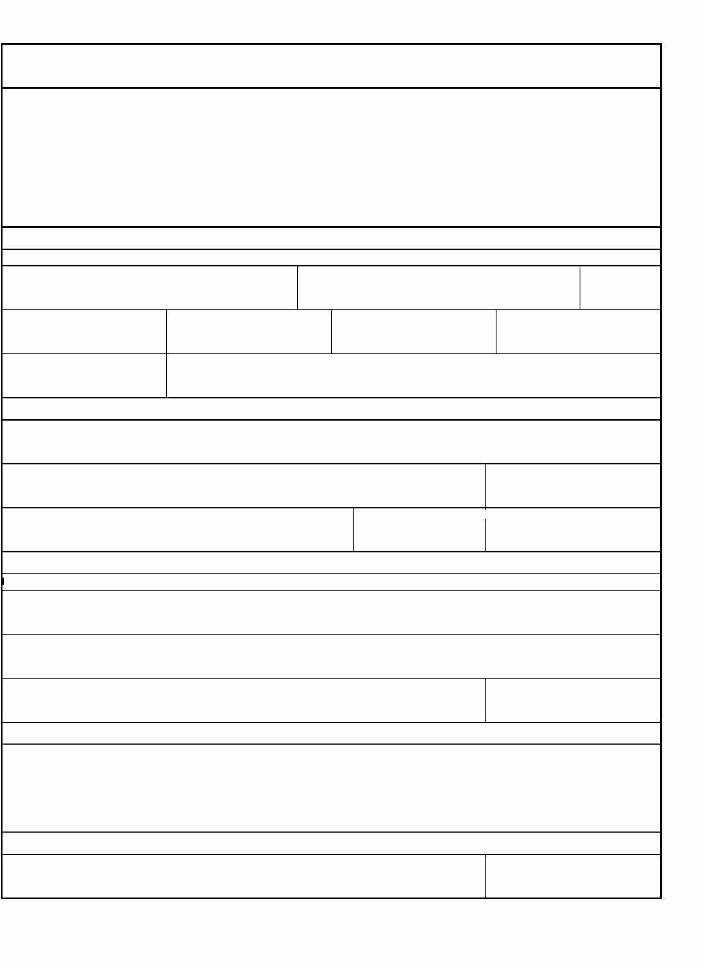
FILLED BY

NGME FORM 001, DEC 2023 ALL PREVIOUS EDITIONS ARE OBSOLETE

CUI
DATE REQUEST FILLED

AEM - FORMS v1.02

